ARCHITECURAL LIGHTING
Create ambient and mood

UPLIGHTING –

STANDARD PAR CANS
Application – Behind Cake Table, Behind Sweetheart Table, Head Table, Illuminate Section

LED PAR CANS
Application – Up-Lighting Walls, Up-Lighting Pillars, Color Wash Effect, Band Lighting, Chasing

UNDERTABLE LIGHTING –

STANDARD LIGHT
Application – Under Cake Table, Under Gift Table, Under Head Table, Under Sweetheart Table

LED MINI-PAR CANS
Application – Sweetheart Table

MONOGRAM PROJECTION –

GOBO LIGHT
Application – Project Your Name or Logo on Floor, Wall or Ceiling.

SPECIAL LIGHTING –

WATER EFFECT
Application – Head Table, Rear Wall, Dance Floor, Ceiling. Provides Texture Motion Effect

BUBBLE MAKER
Application – Used Only for Couple’s First Dance or Waltz

Also Available – Lasers, Foggers, Pin Spot Lights, Mirror Balls, Scanners, LED Lights, etc.

UPLIGHTING –

STANDARD PAR CANS
Application – Behind Cake Table, Behind Sweetheart Table, Head Table, Illuminate Section
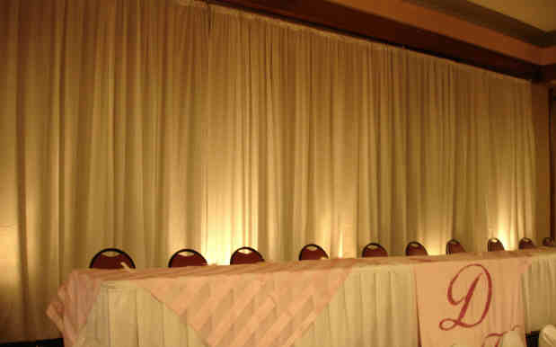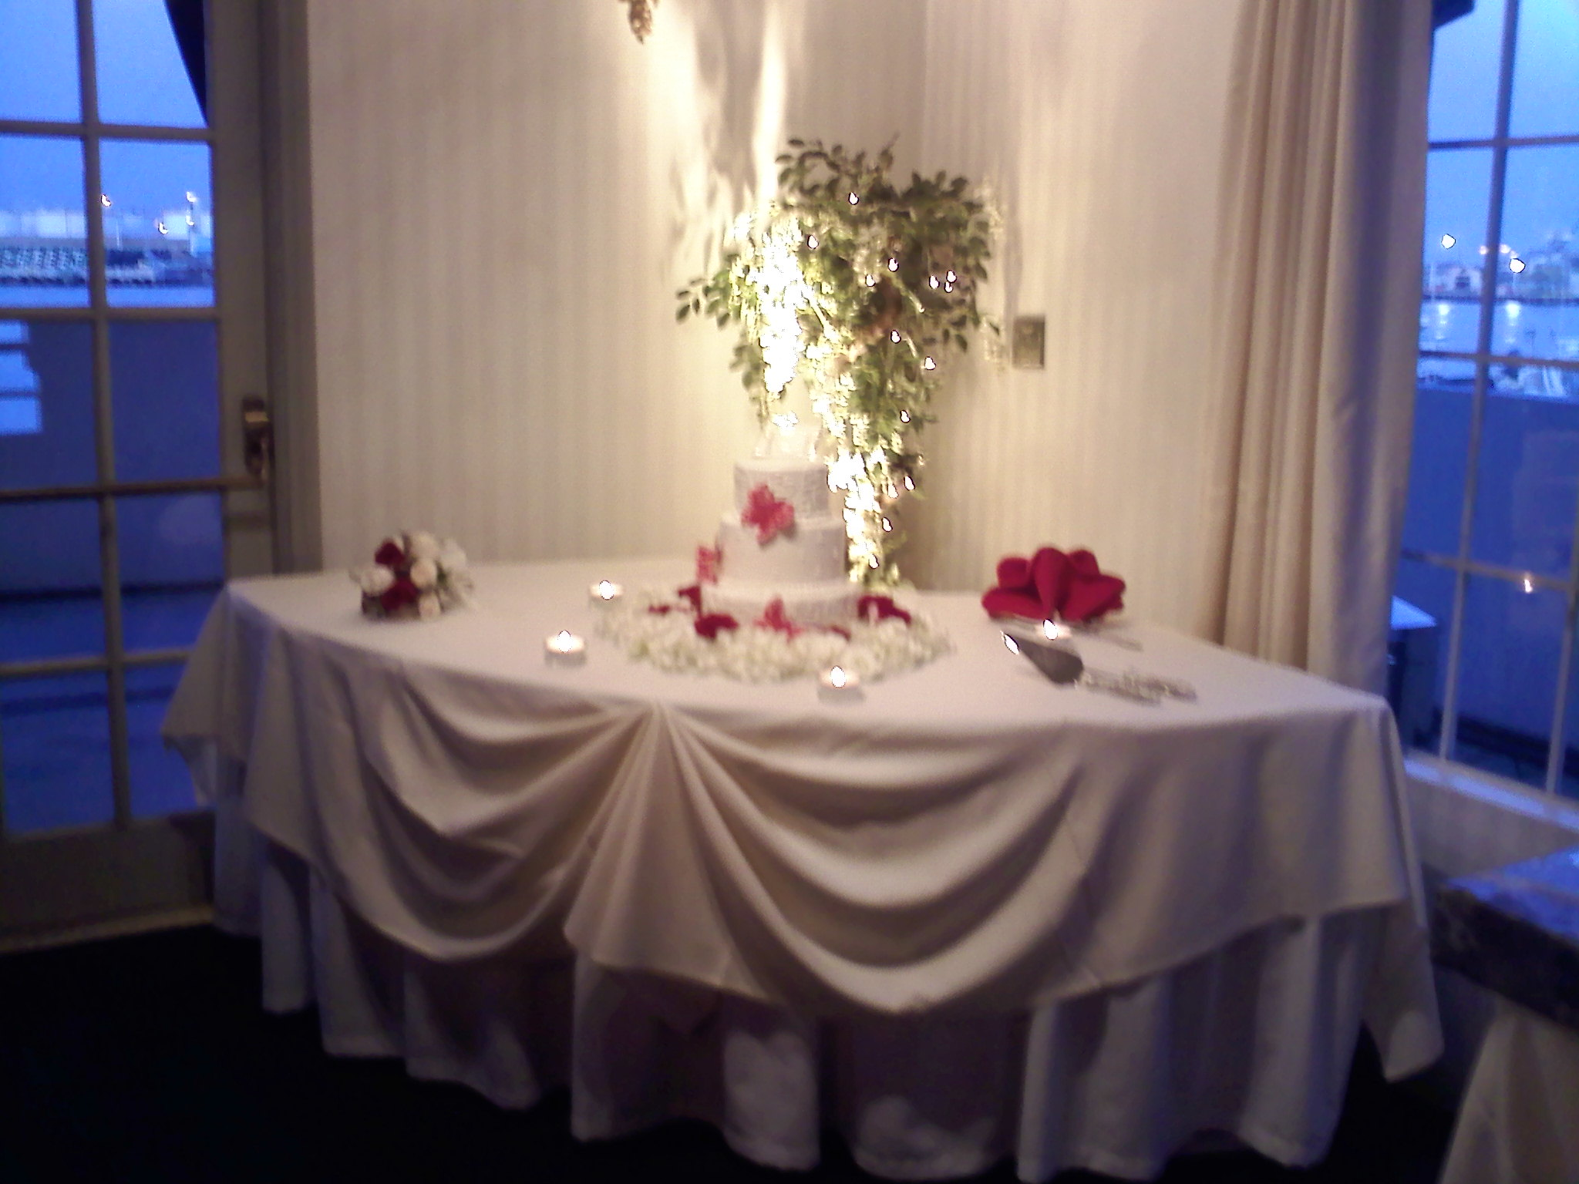

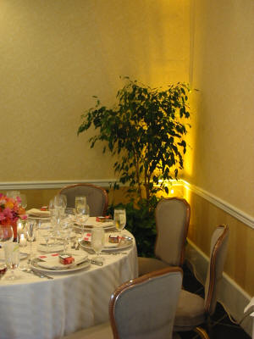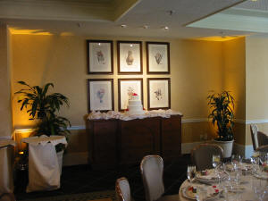

LED PAR CANS
Application – Up-Lighting Walls, Up-Lighting Pillars, Color Wash Effect, Band Lighting, Chasing
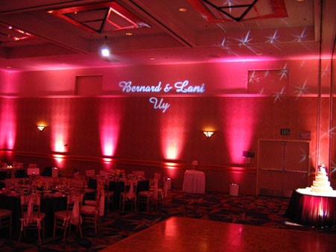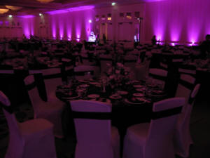

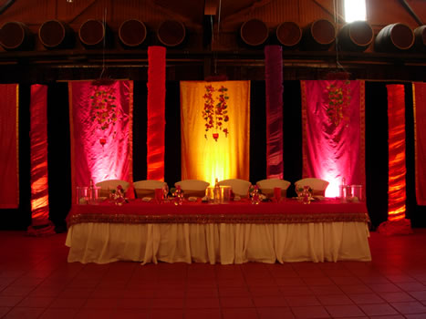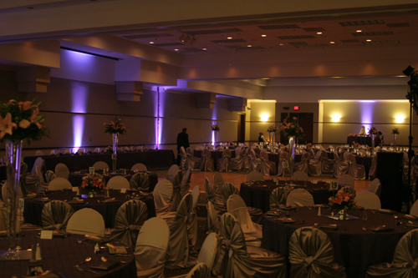

UNDERTABLE LIGHTING –

STANDARD LIGHT
Application – Under Cake Table, Under Gift Table, Under Head Table, Under Sweetheart Table
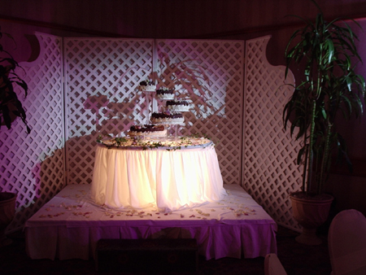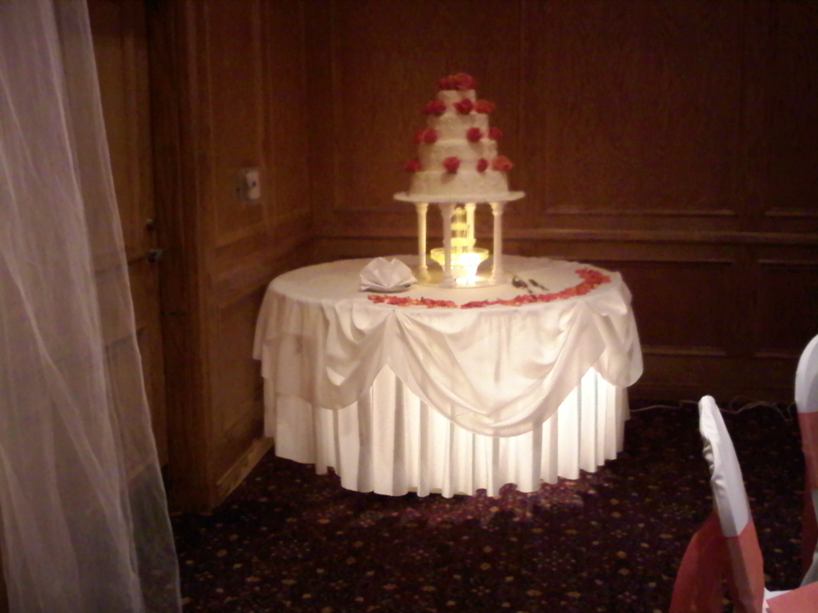

LED MINI-PAR CANS
Application – Sweetheart Table, Any Color.
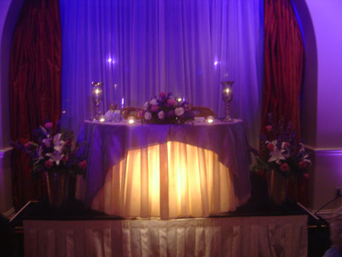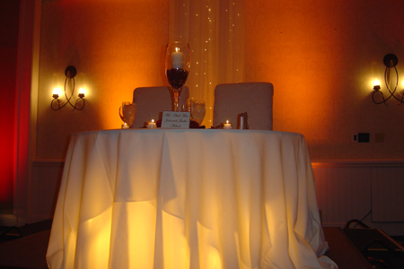

MONOGRAM PROJECTION –

GOBO LIGHT
Application – Project Your Name or Logo on Floor, Wall or Ceiling.
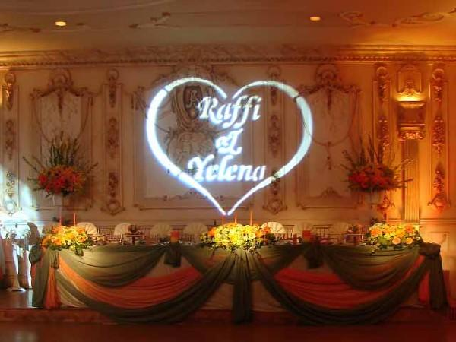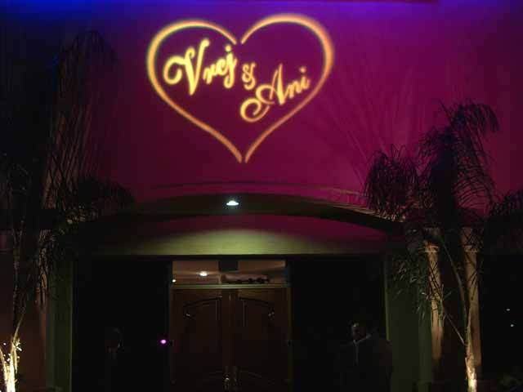

SPECIAL LIGHTING –

WATER EFFECT
Application – Head Table, Rear Wall, Dance Floor, Ceiling. Provides Texture Motion Effect
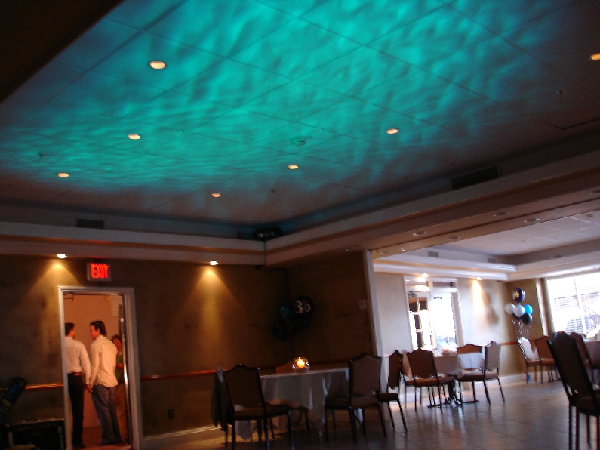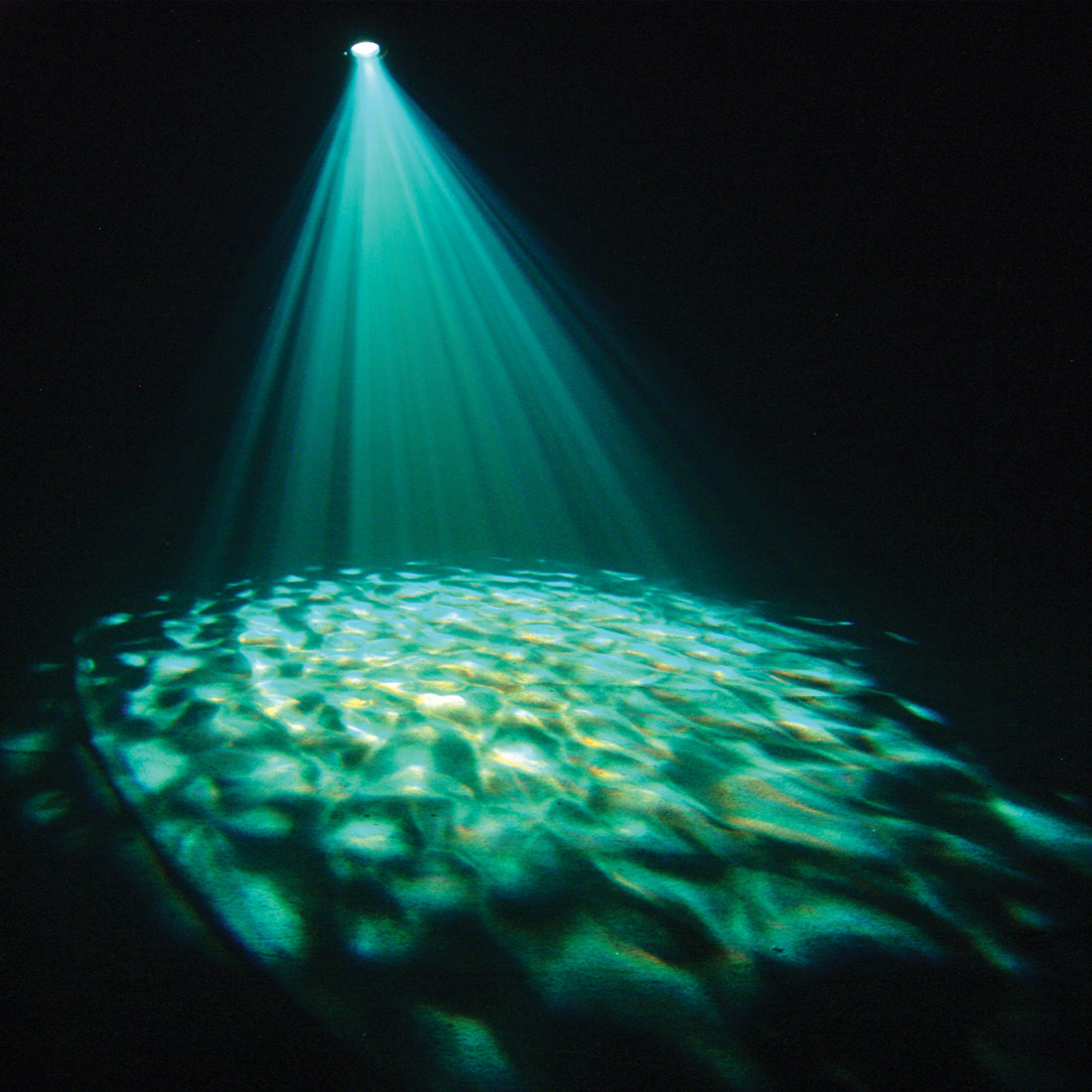

BUBBLE MAKER
Application – Used Only for Couple’s First Dance or Waltz
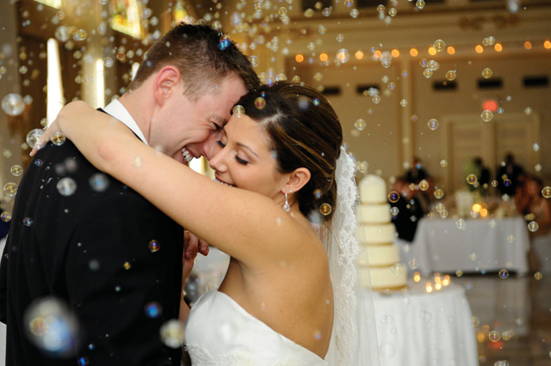

Discount Packages “Various Effects” Require Quote


